My first job interview/ Listening Activity
1. Before Listening / Answer
a. Have you ever been interviewed by anyone? How did you feel? What were you asked?
b. If you haven’t, how do you think you would feel?
c. What kind of questions do you think your interviewer might ask you? Write a list in your notebook.
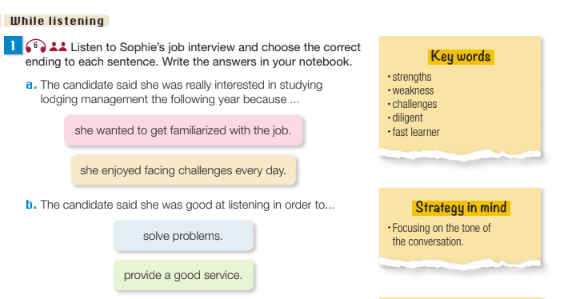
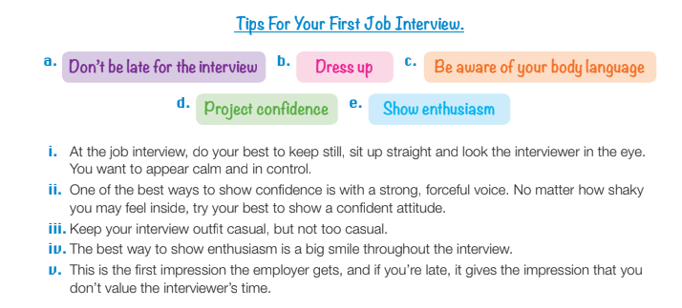
2. Read the labels and match them to the correct statement. (audio 5)
